CT4009-INTRODUCTION TO WEB DEVELOPMENT

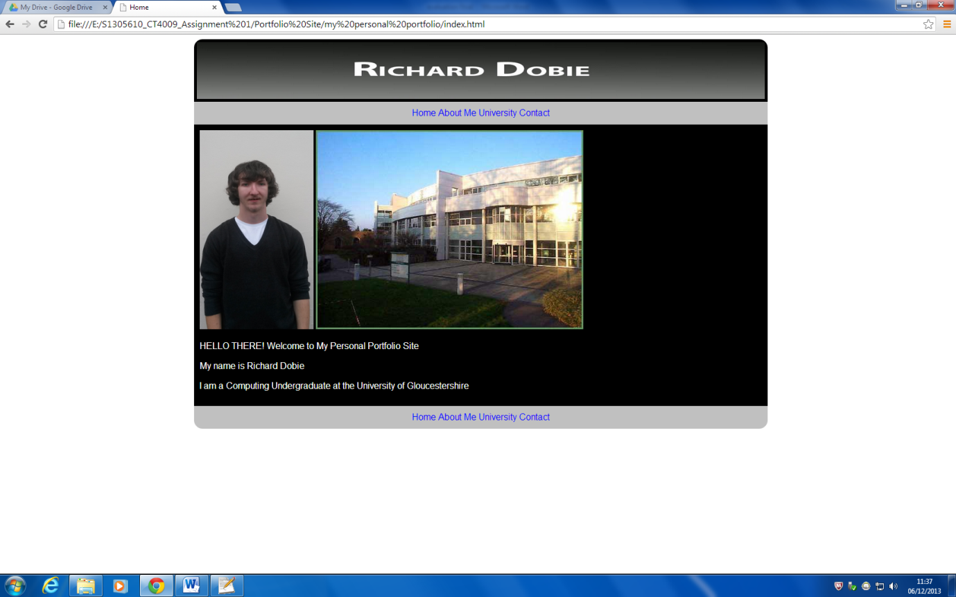

Assignment 1

Richard Dobie-s1305610

# Contents

Contents 2

Introduction 3

WEEK1-WEBSITE CRITIQUE 3

WEEK2-STORYBOARDS&WIREFRAMES 3

WEEK3-INTRODUCTION TO HTML 3

WEEK4-FURTHER HTML 4

WEEK5-INTRODUCTION TO CSS 5

WEEK7-CSS3 6

WEEK8-FURTHER CSS3 7

WEEK9-HTML 5 8

REFERENCES 10

## 

## Introduction

From this assessment the aim was to create a personal portfolio site. In order to create the personal portfolio site each week I completed the tutorial worksheets set. The worksheets acted as a starting point to use the basic structures learnt in the tutorials and adapt and add what I have learnt to my portfolio site so that my portfolio site shows my understanding of the techniques I have learnt each week. In order to create my portfolio site I will use wireframes which will allow me to structure my website. I will use the **\*\* W3C, W3C markup validation service \*\*** validator to check that my portfolio site conforms to the w3schools standards. This assessment was completely new to me as I haven’t done any web development work previously.

## WEEK1-WEBSITE CRITIQUE

The first task set to look at websites and analyse the look of the website as well as the level of interactivity the user has with the site. This task was a good starting point. As a user of the internet I have looked on a lot of websites but had never really analysed them in detail. It is fairly easy to distinguish between a good looking website and a bad looking website however it is another thing to analyse the level of user interactivity and accessibility. From analysing the websites I could begin to understand that it’s not just the layout of a website that’s important. The website analysis gave me an idea of how I should be critical when analysing my portfolio site as I am creating it and thinking about design,layout,use of colour, level of functionality and user interactivity.

## WEEK2-STORYBOARDS&WIREFRAMES

The second task was to produce storyboards and subsequent layouts and wireframes for my portfolio site. To create my wireframes and layouts I based them on the layouts of the websites I had previously analysed in week 1. My initial idea was to keep the layout fairly simple so I decided I wanted a header, navigation, content and footer. My site I wanted to be easy to navigate through and decided I would use a horizontal navigation bar instead of a vertical navigation bar. I found that using wireframes and storyboards was useful as it was easier to plan the structure of my website layout this way and could easily refer back to my wireframes. In using the wireframes I was able to design my portfolio site easier as I had my ideas already planned out. As well as the wireframes I was also able to think about creating colour palettes with the possible colours I would be using for my portfolio site. I also used **\*\*\*\*\*Adobe systems incorporated (2013) \*\*\*\*\*** to create colour palettes

## WEEK3-INTRODUCTION TO HTML

The third task was introducing html tags that would outline the basic structure of the portfolio site. The tutorial exercises introduced me to the Html document structure of a website as well as nesting tags. I also learnt the different html tags that were available to use when structuring my portfolio layout as well as html tags that are known as being deprecated tags meaning they are no longer used or have been replaced with a different tag to do the same formatting. I also learnt about doctype declarations and the importance of doctype declarations which tell the browser which version of html you are using which is important so the browser displays the content correctly. I also learnt about meta tags and keywords which are important to make it easier for you to find your website through a search engine such as google as you declare keywords associated with the website which when you use a search engine it would check if any of the words in the search matched the meta data words declared in your website. The tutorials I used as a starting point to teaching me the basic elements of a webpage such as head, body as well as the basic rules and syntax. The exercises gave me the starting point to then do further research by looking on the website **\* W3Schools,W3schools.com the world’s largest web development site educate yourself beginners and experts \*** which gives tutorials on html and css which I looked at to understand the syntax and rules and then experiment in constructing the basic structure of my portfolio site. From week 3 tutorials I was able to start coding my portfolio site by adding in the doctype declaration aswell as the basic html tags <head> and <body> so that by week 3 I had the basic document structure ready to add to during the following weeks.

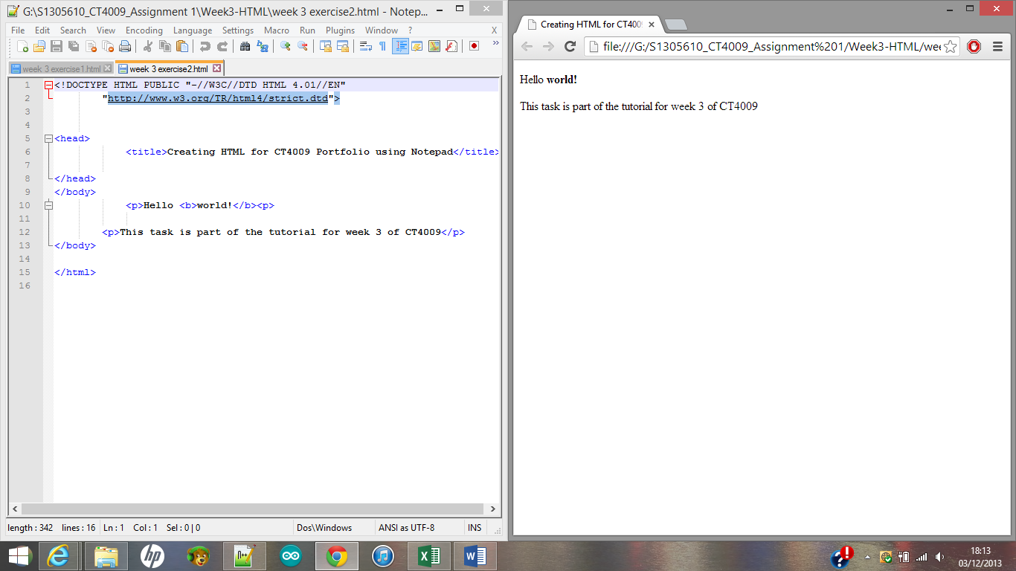

Screenshot showing the html code for a basic document structure of a html page with the result shown in the browser

## WEEK4-FURTHER HTML

Task four introduced me to further html tags. The tutorial tasks introduced what URL’s are and the difference between relative and absolute URL’s. I also learnt about the anchor tag and how to make links which was useful when creating links to the different pages of my portfolio site as well as links to external sites. I also learnt about the target attribute and the importance of the target attribute in terms of making my website accessible to everyone. The target attribute displays text if the image is does not show up on the site. In addition I learnt how to add images to my portfolio site as well as how to use images as links to click on that would take you to external sites. I was also introduced to adding div tags to divide up different sections of my website and how to add background colour to distinguish between the different divs. In week 4 I was able to add more content to my portfolio site such as links between the pages of my site as well as adding images and content using divs. I had problems when adding images to my portfolio site as when I originally put the images within my root directory they were not in separate image folder so the code I wrote looked like this: **<img src="logo1.png" alt="RD" width="140" height="90">** but when I added a sub root directory as images within my main directory I had issues writing the correct code to link to the image correctly. I found out that it was just an easy spelling mistake or syntax error I had made. The new code looked like this : **<img src="images/logo1.png" alt="RD" width="140" height="90">**

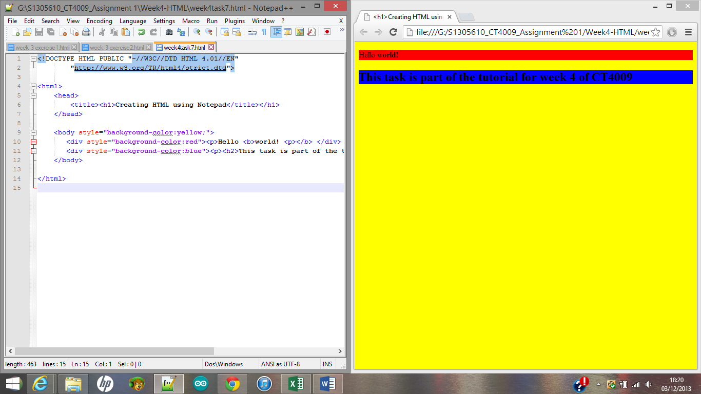

Screenshot showing the html code with divs and formatting styles with the result shown in the browser

## WEEK5-INTRODUCTION TO CSS

Task five introduced me to CSS. The lecture explained the use of CSS as well as the syntax for how to write the CSS. In the tutorial I used the **\* W3Schools, W3schools.com the world’s largest web development site educate yourself beginners and experts \***website to do a quiz about CSS. I then after completing the tutorial took the same quiz again to see the difference which would indicate that I hopefully would get a higher score the second time round. I learnt about using internal style sheets which you declare in the <head> tags within the html page. The tasks taught me the basics of adding background colour and how to style text as well as hyperlinks. I also learnt how to link my html page to an external CSS sheet. The tutorial tasks were a starting point to grasp the basics before trying to add CSS to format my portfolio site. In week 5 I was able to create external style sheets which would allow me to add formatting properties to my divs. I had a simple problem when creating my external style sheets as I had forgotten to add the reference to the style sheet in the head of the html page so when I ran the page in the browser the content styling didn’t work.

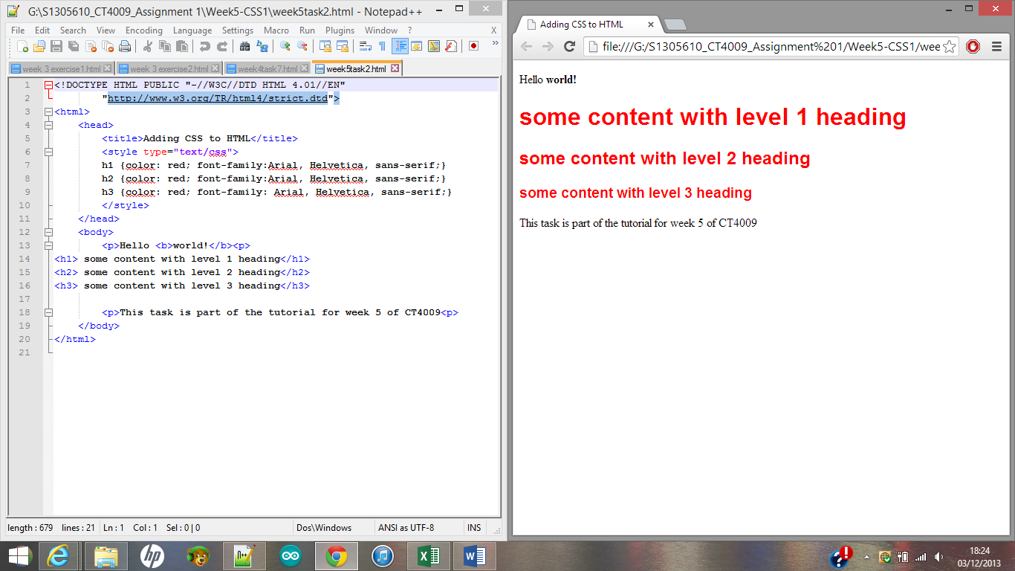

Screenshot showing the html code with different styles for the text with the result shown in the browser

## WEEK7-CSS3

Task 7 introduced the use of css3 to add attributes and values in order to manipulate the style and layout of my portfolio site. The lecture introduced the concept of the box model and components content, padding, border, margin. The box model allows you to format divs which are used to break up the webpage into distinct sections which can be individually styled. The lecture also introduced CSS selectors ID and Class which allow you to style the same elements differently. The syntax for CSS selectors is fairly simple as whatever you call the id or class of the div is the same when you name the CSS. The use of CSS also allows you to define where the div would be relative to a parent element, another element or the browser window itself. The tutorial helped me learn about using id tags for divs which would allow me to style individual divs differently. I also learnt about class selectors and the difference between class selectors and id selectors. Furthermore I learnt how to use descendent selectors for even greater control on the formatting of div content. I also learnt about positioning divs on my website using absolute positioning as well as positioning using liquid css layout which would mean that the divs would stay the same size dependent on the browser and viewport that is used to view my website. To help in understanding liquid layouts I looked in \*\*\***Gillenwater, Z (2009) \*\*\*** at the chapter on adding minimum and maximum widths. To add further CSS to my portfolio site I had an idea that I wanted the images on the about me page of my portfolio site to enlarge when you hover the mouse over them. I searched for ideas for the code and came across **\*\*\*\*JS bin, collaborative JavaScript debugging \*\*\*\***which gave me the code that I needed.

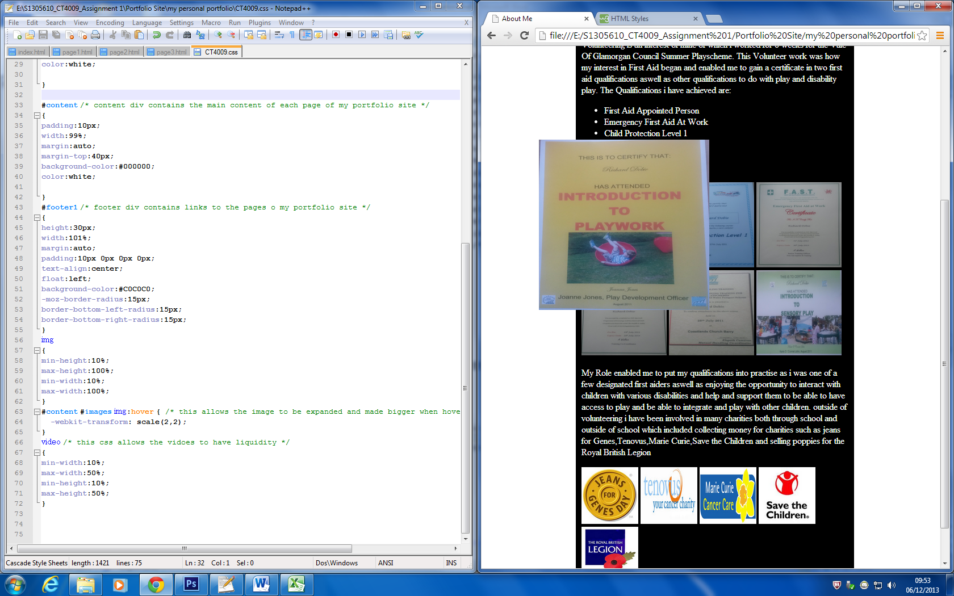

Screenshot showing CSS code to enlarge the images on the about me page within the content div when you hover over them with the mouse with the result shown in the browser

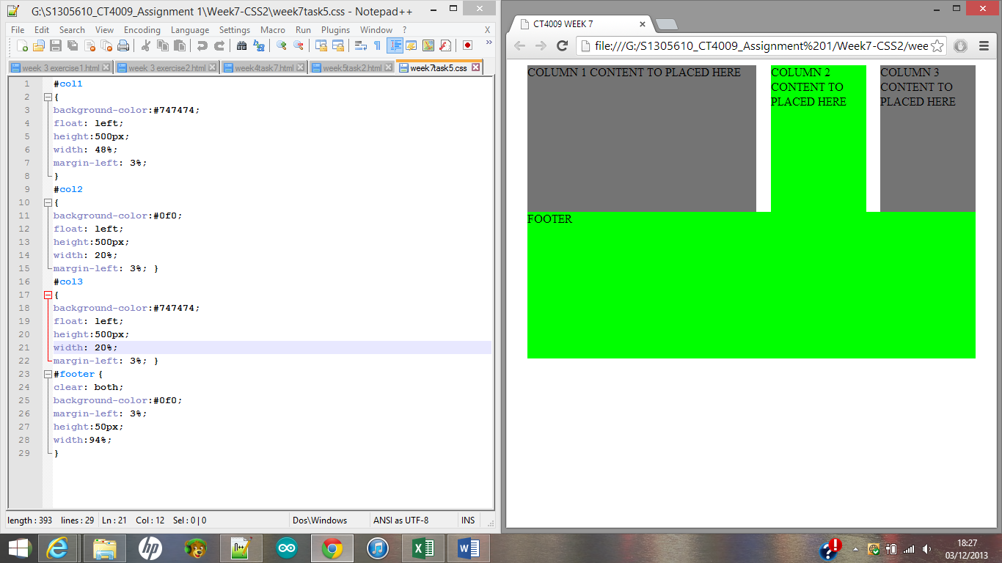

Screenshot showing the html code for positioning divs using css3 style properties with the result shown in the browser

## WEEK8-FURTHER CSS3

Week eight introduced the nested div structure. The structure of using nested divs gives you greater control allowing you to position divs relative to another element using absolute, fixed or relative positioning. The nested divs structure allows you to think of the layout of the page. The parent element is immediately above the element you are targeting. Css3 selectors can be used to target elements more precisely without adding lots of classes or having long compound selector chains. The tutorial introduced using id selectors to create nested divs. I also learnt about using appropriate positional properties. I learnt about pseudo selectors and introduced to some css3 syntax for border radius and text effects.

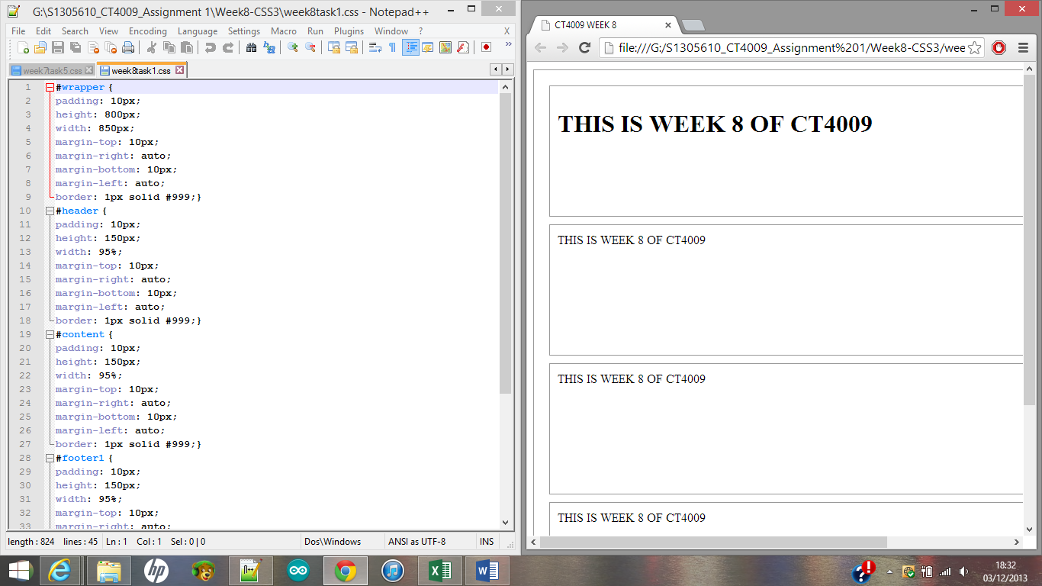

Screenshot of the html code showing the nested div structure with the result shown in the browser

## WEEK9-HTML 5

Week 9 introduced html 5 elements which I could add to my portfolio site. The use of html 5 builds upon previous html code.html 5 is widely used for mobile platforms. In the lecture I learnt that html 5 is defined as in the document object model where as other versions of html are defined as the syntax. The lecture introduced the html 5 structural elements being based around semantic mark-up. If you use normal div tags with id’s such as div id=”header”> the browser doesn’t see the divs as header, footer etc. instead it sees them as different divs. In html 5 the browser can identify different parts of the document. If you use ID’s and classes they create problems as they are not consistent elements and different web developers in different countries will use different mark-up. In html 5 the tags are defined as a consistent set of elements.in html 5 you can add audio and video to websites without the need for a third party plug in. In week 9 I was able to add video content within my portfolio site.

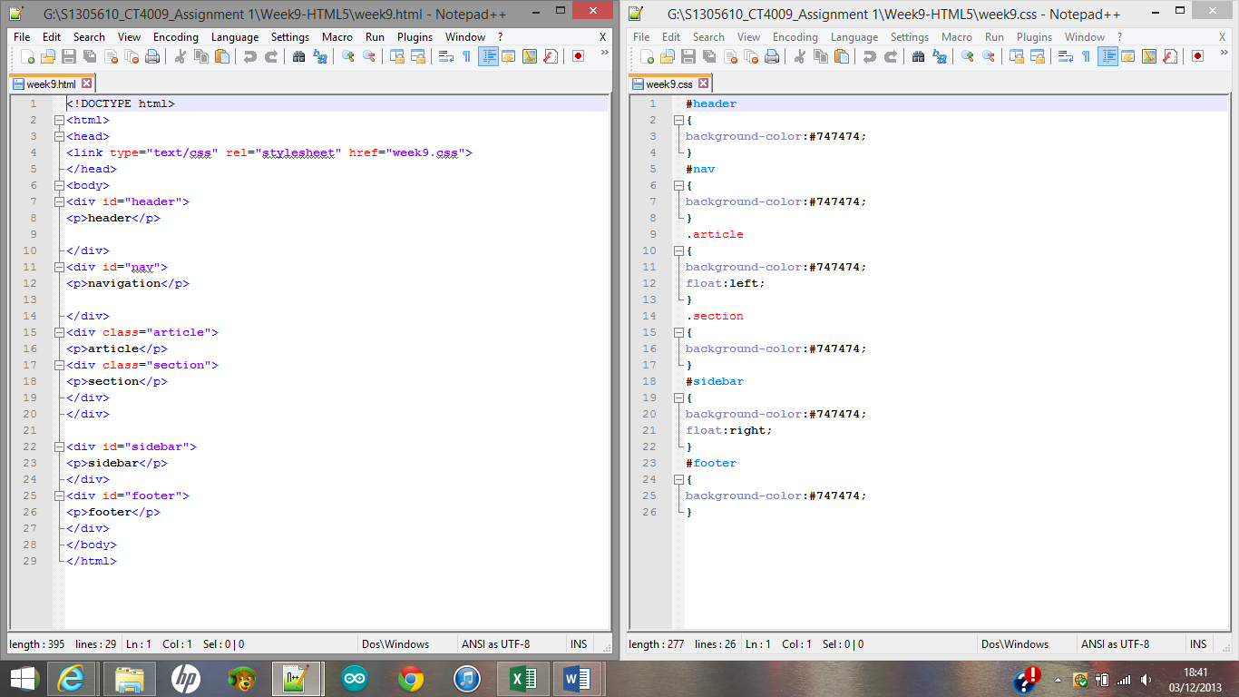

Screenshot showing original html and css code with the result in the browser

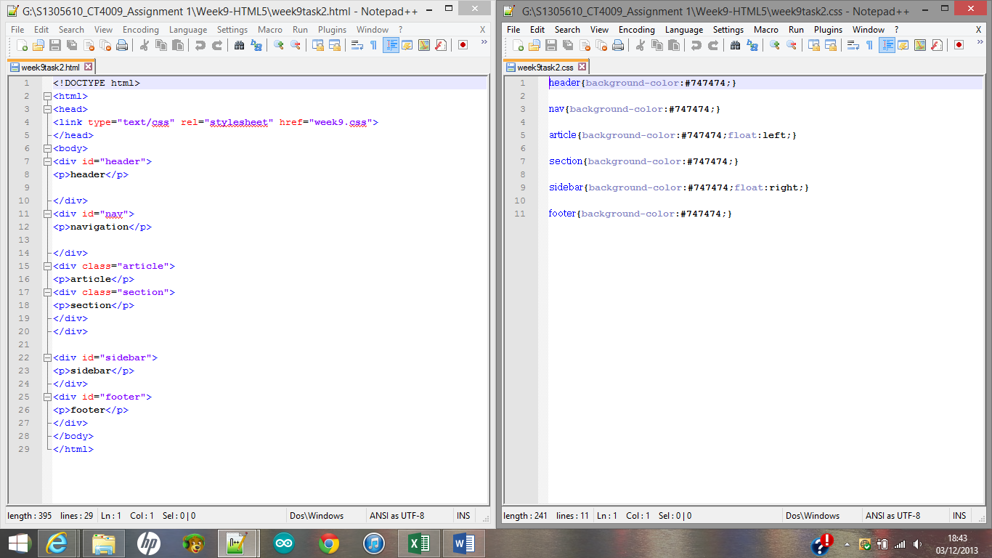

Screenshot showing html 5 code with css with the result shown in the browser

## Evaluation&Future Improvements

In evaluating my final portfolio site against my initial wireframe ideas I have found that my website structure is the same as I wanted it to be. It shows when designing my portfolio site that having a wireframe layout was useful as I had a structure that I just had to replicate. If I was to improve my portfolio site in the future I would look into how to do a slideshow for my images I have added. I would also look into adding audio content and some more graphics with animations. I would also consider different layouts for my website structure and the use of colours I have used. I would try to overall make my portfolio site more interactive for the user.

## REFERENCES

**Websites**

**\*W3Schools, W3schools.com the world’s largest web development site educate yourself beginners and experts, available at** [**http://www.w3schools.com**](http://www.w3schools.com) **(accessed: 21/10/2013)\***

**\*\*W3C, W3C markup validation service, available at** [**http://validator.w3.org/**](http://validator.w3.org/) **(accessed: 05/12/2013) \*\***

**\*\*\*\*JS bin, collaborative JavaScript debugging available at** [**http://jsbin.com/AXaBaya/2/edit**](http://jsbin.com/AXaBaya/2/edit) **(accessed: 05/12/2013) \*\*\*\***

**\*\*\*\*\*Adobe systems incorporated (2013), Adobe Kuler, available at** [**https://kuler.adobe.com/create/color-wheel/**](https://kuler.adobe.com/create/color-wheel/)**(accessed: 03/10/2013) \*\*\*\*\***

**Books**

**\*\*\*Gillenwater,Z(2009)Flexible Web Design creating liquid and elastic layouts with CSS,pages (184-195)Berkeley,CA,New Riders\*\*\***